**Name Goes Here**

Time goes here

**Author goes here**

# 

# **1.Overview**

## **1.1 Introduction**

// What is this game about? What experience does it provide? Use a few sentences..

Guan’s introduction looks like this:

*An experimental 3D narrative walking simulator featuring senses and perception. Under the guidance of a narrator, players traverse through different surreal scenes and are required to interact in unique ways.*

*The game contains puzzles and is densely designed with sound effects, visual effects, and representation of human senses that are intended to create delusion and impressions.*

## **1.2 Metadata**

**Title:** Games name

**Genre:** Experimental / Narrative oriented / Walking Simulator (example)

**Platform:**

**Develop Engine:** name goes here (version number goes here)

**Control:**

**Target Audience:** Players over ? (example)

## **1.3 Production Group**

**Date: ...**

**Members: ...**

**Team Lead:**

**Contacts:** (email goes here)

# **2. Concepts**

## **2.1 Marketing Paragraph**

// What you would put on the game’s steam page? (make it short)

## **2.2 World view**

**2.21 Background:**

// The game’s background and story goes here.

**2.22 Concepts:**

// Define the narrative terms here...

An important concept in Guan looks like this...

Synesthesia: is a neurological condition where stimulation of one sensory pathway involuntarily triggers another, such as seeing colors when hearing music or associating numbers with specific textures.

Impression: Impression in this game stands for the feedback that an object gives off. E.g. the fragrance of flowers. They are visualized and are collectable. They can be used by players to modify objects / construct scenes / build stories

# **3 Game Direction**

## **3.1 References**

// What works inspires you? Guan looks like this:

***Art Direction:***

***Reference:***

***Narrative Direction:***

***Narrative Structure Reference:*** *The Stanley Parable, The Beginner’s Guide*

***Narrative UI Reference:*** *What Remains of Edith Finch*

***Mechanic Direction:***

*Reference: Superliminal*

***VFX Direction:***

***Reference:*** *The Unfinished Swan*

## 

## **3.2 Design**

// Guan’s design looks like this

***Art Direction:***

*Concepts:*

*Low-poly objects and scenes rendered with unique shaders (e.g. pixelation, vaporize, grainy…)*

*Objects’ models and the shaders/PPV should cover their unnecessary details. Only their sensory values, shown as the features that give off unique feedback, should be emphasized. Their sense of object should be unified.*

***Narrative Direction:***

*Concepts：*

***The game is inconsistent in narration:***

*(1): There is no clear / consistent storyline during the whole game. The only consistency is experience.*

*(2): Narrations exist heavily in some scenes and mildly in some scenes. Story Immersion is not the priority, narration is rather functional and designed for experimental purposes. (e.g. trying to have the players pairing different senses)*

***The game has a consistent narrator:***

*(1): Shown as a narrator or voice throughout the process. It provides guidance and reminds the players of their identity and reality.*

*(2): Shown as 3D / 2D text that might be directly shown in the scenes. Text is a necessary part of visual cues.*

***The game is divided into scenes:***

*(1): The game consists of scenes that feature different experiences and entails different concepts.*

***Mechanic Direction:***

*Concepts:*

*The game manipulates perception. It centers subjectivity and objectivity, attributes of objects and how people understand their existence.*

*E.g. The game features deconstructivism and an object is deconstructed into how people feel about it in their 5 senses.*

***VFX Direction:***

*Concepts: The game contains substantial VFX that visualize the “feelings of objects”, “sound”, “smell” and “taste”. The game also utilizes VFX to curb the player’s view, such as making a scene unrecognizable.*

# 

# **4. Mechanics**

## **4.1 Interactions**

// What can the player do? List the actions (open doors, type in code, steer the spaceship)

## **4.2 Player controls:**

// What are the controls? Guan’s control looks like this...

|  |  |
| --- | --- |
| *Hardware Input* | *Result* |
| *Mouse movement* | *First Person head direction* |
| *‘W’ / ↑* | *Forward* |
| *‘S’ / ↓* | *Backward* |
| *‘A’ / ←* | *Leftward* |
| *‘D’ / →* | *Rightward* |
| *‘Shift’* | *Run* |
| *‘E’ / Left Mouse Button* | *Interact / Select / Collect / Apply* |
| *‘F’ / Right Mouse Button* | *Observe / Listen / Feel…* |
| *‘Space’* | *Close eyes / ears…* |
| *…* | *…* |

**Interactable Behaviors:**

// How do the items behave? Guan’s table looks like this...

|  |  |
| --- | --- |
| *Behavior* | *Target* |
| *Move / Run* | *Self / Ground* |
| *Observe* | *Object Facing* |
| *Close eyes* | *Self* |
| *Interact* | *Objects* |
| *Collect / Absorb* | *Impressions* |
| *Apply / Modify* | *Object’s status* |
| *…* | *…* |

## 

## **4.3 System Design**

// What systems do you have? Collecting and harvest system?

# 

# **5. Game Flow**

## **5.1 Level Design**

// How are levels organized?

Scene Series 1 for Guan looks like this:

***Concept:***

*There are 2 scenes, 1.11 and 1.12. They are similar scenes that have weak visuals . They share similar or same sound effects that are given off by objects in similar spatial arrangements. Players navigate from the starting point to an exit door solely by sound effects.* ***1.11 is an Old Cabin in a heavy rainstorm. 1.12 is a Jazz Bar***

***Visual:*** *Stylized scene with almost no visibility. Objects are all covered in fog, which reduces when players walk past (only on the right path) There are four main objects in both scenes that will be well-rendered and lit.*

***Sound:***  *Sound effect of objects are essentially clips being played repetitively in a certain rhythm: e.g. the door makes sound that lasts 6 seconds every time, 2 seconds in between. In the table, corresponding objects give off the same or similar sound. When players go across the whole scene, volume increases and a full soundscape will be displayed.*

***Controls:*** *WASD to move*

***Text / UI:*** */*

### 

|  |  |  |  |  |
| --- | --- | --- | --- | --- |
| ***Scene 1.11: Old Cabin*** | ***Door in the wind*** | ***Fireplace***  ***crackling*** | ***Wind chimes by another window*** | ***Television playing shows*** |
| ***Scene 1.12: Jazz Bar*** | ***Trumpet Player playing*** | ***Old Vinyl spinning by the butler*** | ***Bartender preparing glass cups*** | ***Customers chatting and chilling*** |

// What are the levels like? Put a level design map here

Here’s a level design of a game I made long ago...

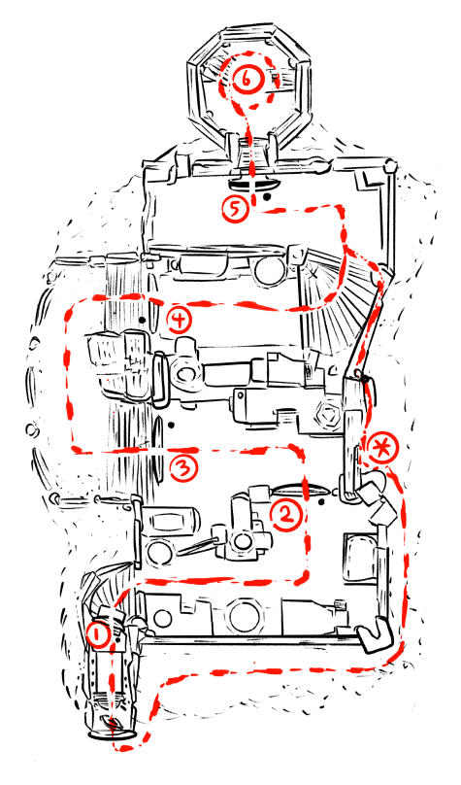

## 

## **5.2 Game Loop**

// Most important because your game is a looping structure

Draw a branching map for the sequence of player actions

Here’s a game loop map of a game I made long ago...

### 

# 

# **6. Artist / Designer Statement**

// What makes you make a game like this? I have this part simply because it’s a good place to sort out my design approach because I make games out of artistic expressions

# **7. User Interface**

// Define all the UI needed

# **8. Script**

// All the text that will be displayed

# 

# 

# 

# 

# **9. Development Notes**

## **9.1 Programming, Engine & Development:**

// Note down the issue in detail and leave behind your name, date and time

## 

## **9.2 Art & Technical Arts:**

// Note down the issue in detail and leave behind your name, date and time

### 

### **9.2.1 3D Art:**

**Modelling, Texture, Animation tab**

### **9.2.2 Environment:**

**Scene building, Environmental art tab**

### **9.2.3 Rendering:**

**Rendering, Shaders and stylization tab**

# **10. Randoms**

// Leave random notes here

**Guan example:**

Scene 1.1 structures done before 3.20

Including movements, 4 scenes constructions

Scene concepts for 1.1 will be done by the end of spring break

Scene 1.1.0 and 1.1.1 will be done by the end of spring break

Scene scene 1.1.2 will be done by the end of 3/16

Scene 1.1.3 will be done as much as possible before 3/21

Players Go through the whole thing, being able to choose direction

**Beta:** 3/21/25

Scene 1.2 concept done before 3/31

Scene 1.2.1 & 1.2.2 framework constructed by 3/31

Scene 1.2.1 & 1.2.2 built by 4/6

Scene 1.3 concept and scene 3.1 concepts built by 4/13

Scene 3.1 main mechanics done by 4/18

**Pre-Release** 4/18/25

**Game Creation Society x IDeATe x ETC joint release:** 4/25/25